1. Include A README file that contains
   * A brief description of the project
   * Installation instructions
   * A short example/tutorial
2. Allow issue tracker for others
3. Write an API documentation
   * What a function do
   * What the function's parameters or arguments are
   * [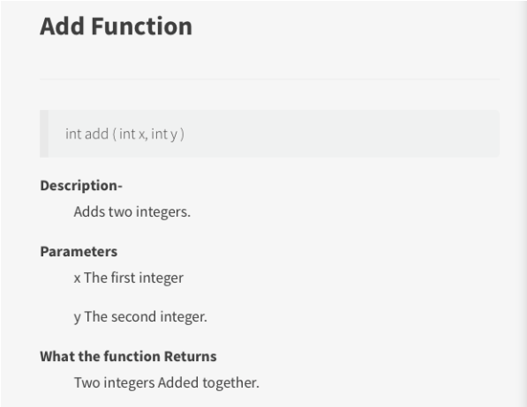](https://libapps.s3.amazonaws.com/accounts/125446/images/function_example.png)What a function returns

An example for code documentation.

1. Document your code
2. Apply coding conventions, such as file organization, comments, naming conventions, programming practices, etc.
3. Include information for contributors
4. Include citation information
5. Include licensing information
6. Link to your e-mail address at the end
7. List all the version of the files along with the major edits you did in each version

GRAPHS  
by Ken Carlo Javier and Benjamin Elevazo

Description:

This projects aims to create a a graph simulator.

Issues:

* Not yet done.
* Still figuring out how to connect vertexes.
* Algorithms for different graphs not yet been coded.

APIS

Functions used

1. AddVertex()

Description: Allows us to add vertex to the canvas by locating the mouse clicks.

Parameter:

x = the horizontal location of mouse click.

Y = the vertical location of mouse click.

canvas = represents the ID element “CanvasArea”

context = represents the “2d” context.

rect = returns the size of the canvas and its position relative to viewport.

DAILY RECORD

March 21

March 22

March 23, 2020

* 1:03pm Added pointer events